Theory of Everything
David Adams
October 28, 2025

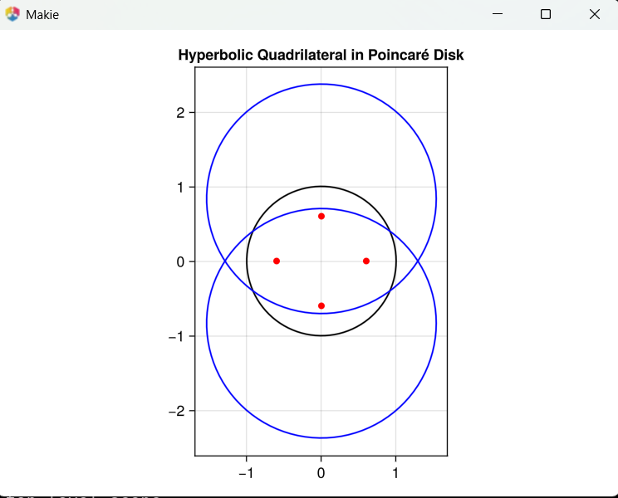
using GLMakie, LinearAlgebra

# Poincaré disk model: map hyperbolic lines to Euclidean circles/lines
function hyperbolic_line(x1, y1, x2, y2)
# Check if the line is a diameter (special case)
if abs(x1 - x2) < 1e-10 && abs(y1 + y2) < 1e-10
return [(x1, t) for t in range(-1, 1, 100)]
elseif abs(y1 - y2) < 1e-10 && abs(x1 + x2) < 1e-10
return [(t, y1) for t in range(-1, 1, 100)]
else
# Find the center and radius of the circle representing the hyperbolic line
# Solve for (a, b, r) in (x-a)² + (y-b)² = r²
A = [x1^2 + y1^2 - 1 x1 y1;
x2^2 + y2^2 - 1 x2 y2;
1 0 0]
b = [1; 1; 0]
sol = A \ b
a, b, r = sol[1]/2, sol[2]/2, sqrt(sol[3] + (sol[1]/2)^2 + (sol[2]/2)^2)
# Parametric points on the circle
θ = range(0, 2π, 100)
return [(a + r*cos(θi), b + r*sin(θi)) for θi in θ]
end
end

# Vertices of a hyperbolic quadrilateral (approximate regular)
vertices = [(0.6, 0.0), (0.0, 0.6), (-0.6, 0.0), (0.0, -0.6)]

# Plot the Poincaré disk and the hyperbolic quadrilateral
fig = Figure()
ax = Axis(fig[1, 1], aspect = DataAspect(), title = "Hyperbolic Quadrilateral in Poincaré Disk")
# Draw the boundary of the Poincaré disk
lines!(ax, [cos(θ) for θ in range(0, 2π, 100)], [sin(θ) for θ in range(0, 2π, 100)], color = :black)
# Draw the hyperbolic quadrilateral
for i in 1:4
j = i % 4 + 1
line = hyperbolic_line(vertices[i][1], vertices[i][2], vertices[j][1], vertices[j][2])
lines!(ax, [p[1] for p in line], [p[2] for p in line], color = :blue)
end
scatter!(ax, [v[1] for v in vertices], [v[2] for v in vertices], color = :red)
ax.aspect = DataAspect()
fig

If we look at this code block we can see that the naming convention is imperative. This is similar to labeling in science and artificial neural networks. If we get the following:
julia> square_minus_circle_1 = circle_area_1 - square_area_1
-21.46018366025517

julia> square_minus_circle_1 = square_area_1 - circle_area_1
21.46018366025517

julia> square_minus_circle_1 = square_area_1 - circle_area_1
21.46018366025517

julia> circle_minus_circle_1 = circle_area_1 - square_area_1
-21.46018366025517

julia>
The answers are corrected but which do we reject? If we understand combinations and the N versus NP problem, we can understand the explosion problem.

Thurston’s Geometrization Conjecture states:
Every compact, orientable 3-manifold can be cut along essential tori and Klein bottles into pieces, each of which admits a complete geometric structure modeled on one of the eight geometries above.
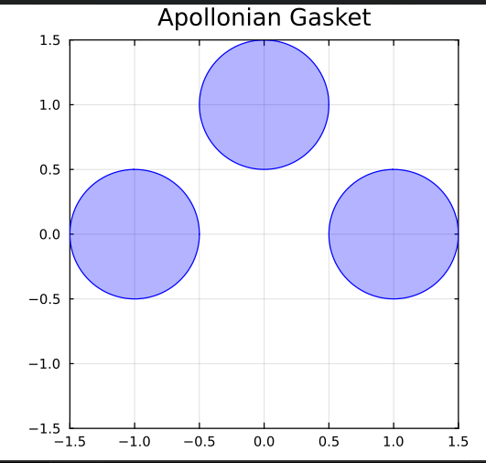

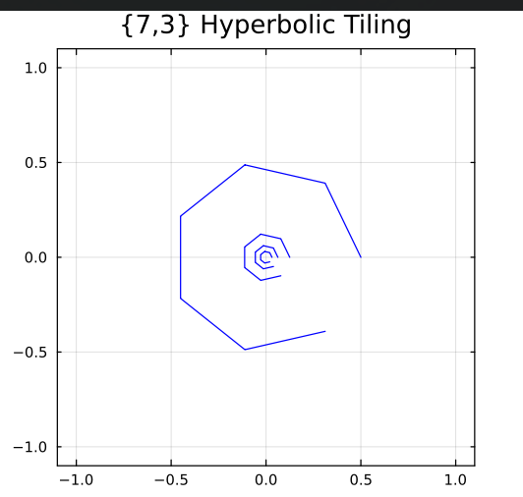

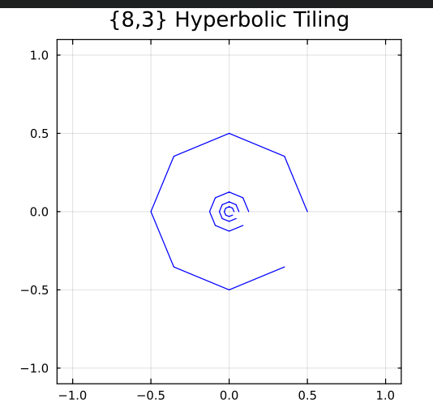
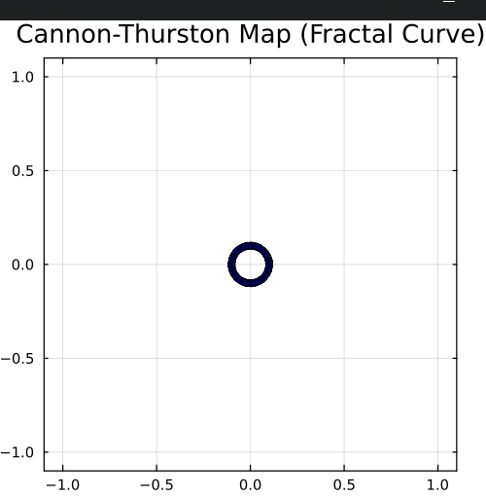
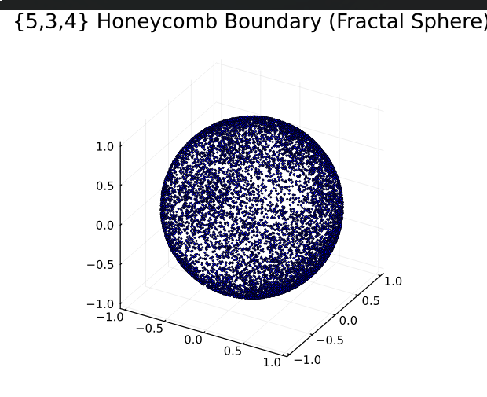

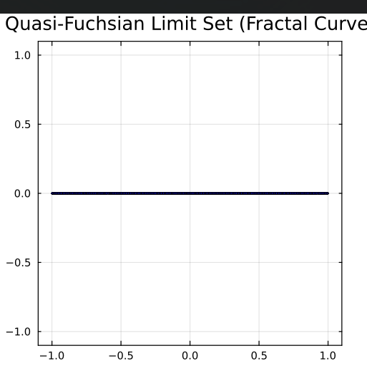
Example | Julia Function | Description
Schottky group | schottky_limit_set() | Cantor set on the boundary of $H^{3}$H3.
Apollonian gasket | apollonian_gasket(n) | Fractal circle packing.
{7,3} tiling | poincare_disk_tiling(n) | Heptagonal tiling of $H^{2}$H2.
{8,3} tiling | poincare_disk_tiling_83(n) | Octagonal tiling of $H^{2}$H2.
Cannon-Thurston map | cannon_thurston_map() | Fractal curve on the boundary of $H^{3}$H3.
{5,3,4} honeycomb | honeycomb_boundary() | Fractal sphere boundary of a 3D tiling.
Quasi-Fuchsian group | quasi_fuchsian_limit_set() | Fractal Jordan curve.
